|  |  |
| --- | --- |
| Project Name | Containment Zones Alerting |
| Maximum Marks | 4 Marks |

# Step-1:

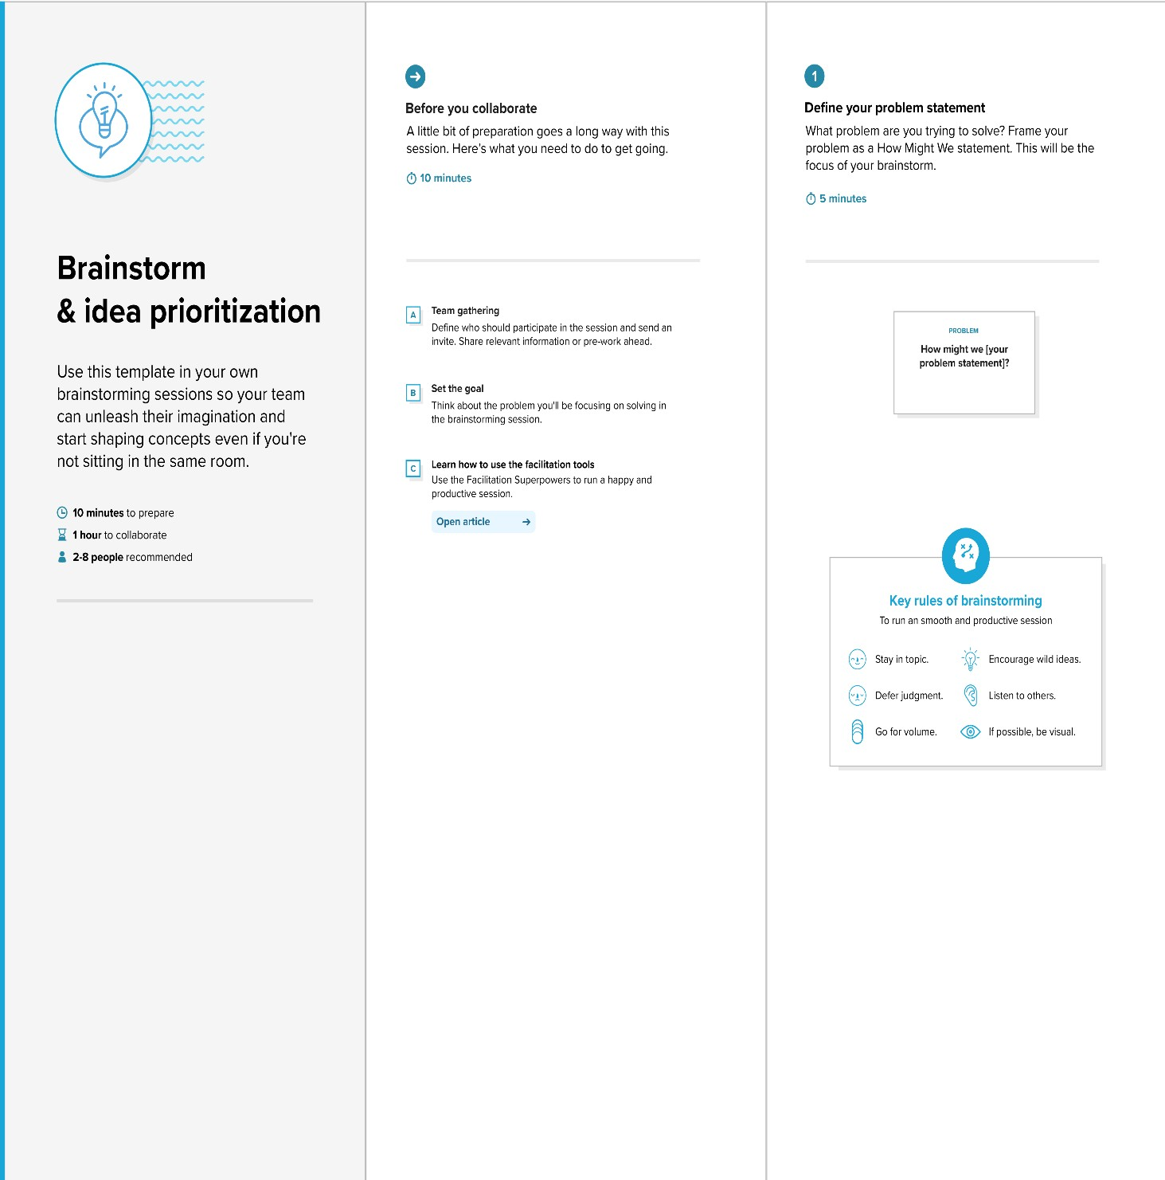

Step-2:

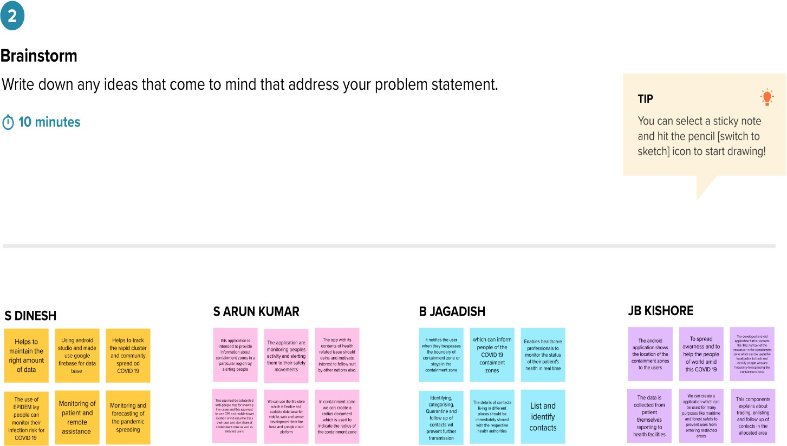

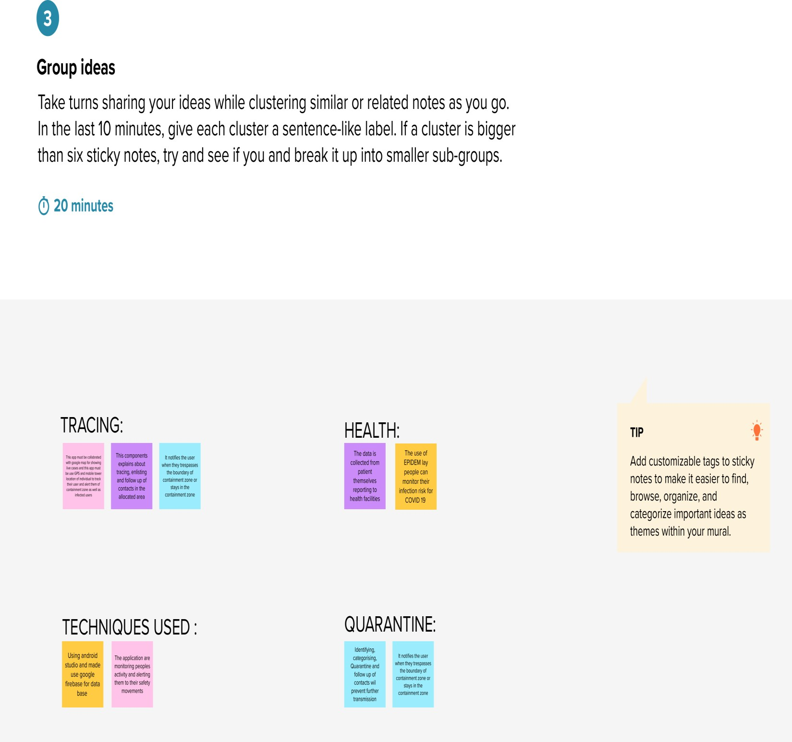

# Step-3:

